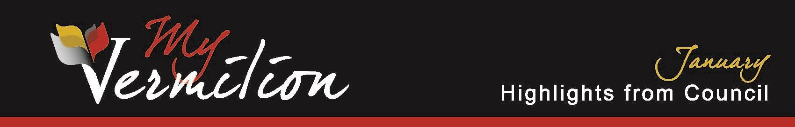

**January 21, 2025**

# Delegations

## Northern Lights Library System – James MacDonald

Executive Director James MacDonald went through the 2024 Value Statement for the Northern Lights Library System and the Vermilion Public Library sharing lots of positive numbers.

Mr. MacDonald also shared the top three milestones for 2024 and the top three initiatives for 2025 for the Northern Lights Library System.

# Old Business

## County of Vermilion River and Town of Vermilion Fire Services Agreement

Council defeated a motion to postpone amending and extending the Fire Services Agreement between the County of Vermilion and the Town of Vermilion.

Council carried a motion to amend the Fee for Use of Town Owned Equipment in the Fire Services Agreement between the County of Vermilion River and the Town of Vermilion.

## Intermunicipal Collaboration Framework Agreement

Council carried a motion to accept the County of Vermilion River’s request for a 2-year extension on the Intermunicipal Collaboration Framework Agreement.

# New Business

## Public Commentary

Shawn Jacula expressed concerns regarding his previously submitted questions not being answered to the extent he was looking for.

## 2025 General Municipal Election Returning Officer and Deputy Returning Officer

Council carried a motion to appoint Madison Barrett as the Returning Officer and Marylee Prior as the Deputy Returning Officer for the General Municipal Election to be held on October 20, 2025.

*These Highlights of Council are an informative summary only, as official minutes of the meeting will be approved at the next regular meeting of council.*

1 | P a g e