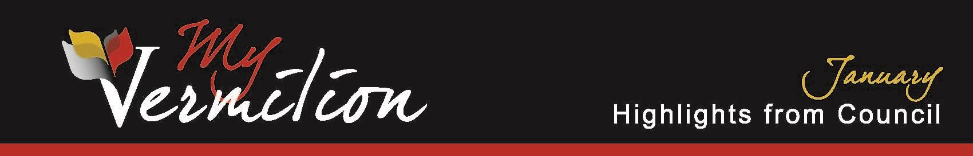

**January 7, 2025**

**New Business**

# Capital Budget Amendments – RCMP Building Roof Funding

Council approved an amendment to the 2024 Capital Budget to add a third-party contribution of $33,000 to the RCMP Building budget.

**Sewer Trunk Main Funding**

Council gave first reading to Borrowing Bylaw 1-2025 in the amount of $2,250,000.

**Operating Line of Credit**

Council gave all three readings to the Operating Line of Credit Bylaw 2-2025.

# Fire Services Agreement

Council defeated a motion to extend the Fire Services Agreement between the County of Vermilion River and the Town of Vermilion.

# Intermunicipal Collaboration Framework Agreement

Council defeated a motion to accept the County of Vermilion River’s request for a 2-year extension on the Intermunicipal Collaboration Framework Agreement.

*These Highlights of Council are an informative summary only, as official minutes of the meeting will be approved at the next regular meeting of council.*

1 | P a g e